H.T No
Regulations:
A18

Sreenidhi Institute of Science and Technology
(An Autonomous Institution)
Code No: 7HC08 Date: 03-Nov-2021 (AN)

B.Tech I-Year II- Semester External Examination, Oct/Nov-2021 (Supplementary)
ENGINEERING MATHEMATICS-II (CIVIL, EEE, ME and ECE)

Time: 3 Hours Max.Marks:70

Note: a) No additional answer sheets will be provided.
b) All sub-parts of a question must be answered at one place only, otherwise it will not be valued.
c) Missing data can be assumed suitably.

ANSWER ANY 5 OUT OF 8 QUESTIONS. EACH QUESTION CARRIES 14 MARKS.

Bloom's Cognitive Levels of Learning (BCLL)

Remember | L1 | Apply | L3 | Evaluate | L5
Understand | L2 | Analyze | L4 | Create | L6

 |  |  | BCLL | CO(s) | Marks
1. |  | Verify Gauss divergence theorem for 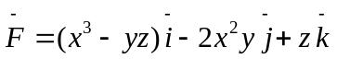 taken over the surface of the cube bounded by the planes 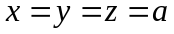and the coordinate planes. | L6 | CO1 | [14M]
2. | a) | Solve | L3 | CO2 | [7M]
 | b) | Solve given that . | L3 | CO2 | [7M]
3. | a) | Solve . | L3 | CO3 | [7M]
 | b) | Solve . | L3 | CO3 | [7M]
4. | a) | Express 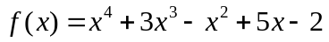 in terms of Legendre polynomial. | L5 | CO4 | [7M]
 | b) | Express 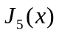in terms of 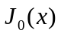 and 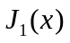. | L4 | CO4 | [7M]
5. | a) | Determine the analytic function whose imaginary part is 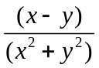. | L5 | CO5 | [7M]
 | b) | Determine Harmonic conjugate of 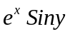 | L5 | CO5 | [7M]
6. |  | Evaluate 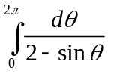by residue theorem | L5 | CO6 | [14M]
7. | a) | A body originally at cools down to in minutes, the temperature of the air being . What will be the temperature of the body after minutes from the original? | L3 | CO1 | [7M]
 | b) | Solve by method of variation of parameters. | L3 | CO2 | [7M]
8. | a) | Determine the bilinear transformation which maps the points z = 1, i, –1 onto the points w = i, 0, –i . | L5 | CO4 | [7M]
 | b) | Evaluate 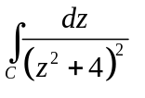 where 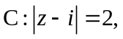by residue theorem. | L5 | CO5 | [7M]

-- 00 -- 00 –

